## DAY 5: EVENING ASSESMENT

1. What is an instance method in Python? (Explain with a simple example.)

An instance method is a function defined inside a class that operates on a specific instance of the class. It takes self as the first parameter, which refers to the object calling the method.

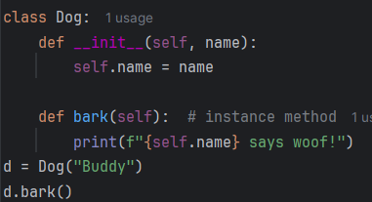

1. Write a class `Car` with an instance method `start_engine` that prints "Engine started."

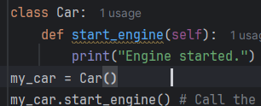output: Engine started.

1. How do you call an instance method — with the class name or with the object? (Give example.)

call an instance method using the object, not the class name directly

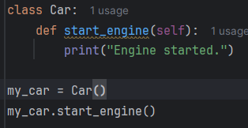

1. Create a class `Circle` that takes radius in `__init__` and has an instance method `area()` to calculate the area of the circle.

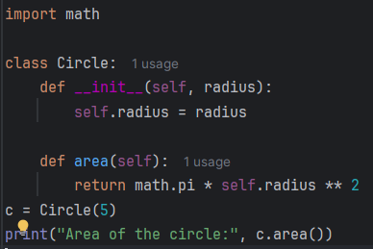output: Area of the circle: 78.53981633974483

1. What will happen if you try to call an instance method without creating an object?

If you try to call an instance method without creating an object, Python will raise a TypeError, because the method expects a self

1. What is a class method? How is it different from an instance method? (Answer with example.)

class method is a method that is bound to the class, not the instance. It operates on the class itself and receives the class as the first argument, conventionally named cls

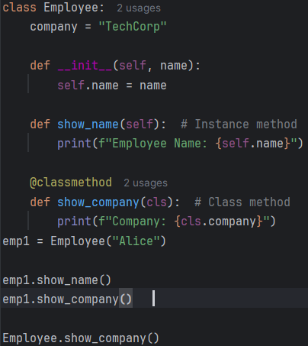

1. Write a class `Employee` with a class variable `company = "TechCorp"` and a class method `get_company_name()`.

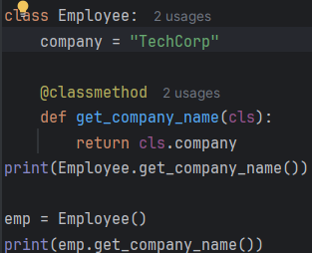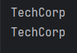

1. How do you define a class method? (Which decorator is used?)

To define a class method, you use the @classmethod decorator

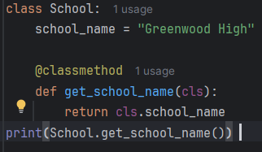output: Greenwood High

1. Create a class `Counter` with a class variable `count` and a class method `increment()` that increases the count by 1.

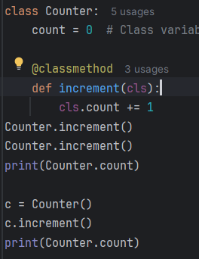output:2 3

1. What is a static method in Python? (Explain with example.)

A static method is a method that does not depend on the class or instance

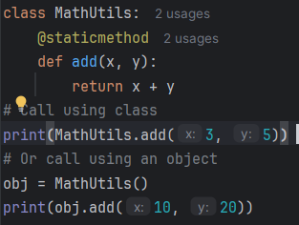

Use @staticmethod when the method doesn't need access to instance (self) or class (cls) data.

1. Write a static method `is_even(num)` inside a class `MathUtils` that returns `True` if the number is even, else `False`.

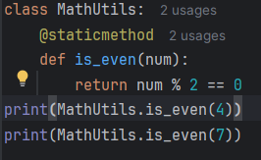output: True

False

1. Which method type should you use when:  
   - You want to access/modify class variables — (Instance/Class/Static)?  
   Class Method **(@**classmethod): Receives the class (cls) as the first argument. Can access or modify class-level variables  
     
   - You don’t need class or instance data — (Instance/Class/Static)?

Static Method (@staticmethod): Receives no self or cls. Independent utility logic that belongs in the class context logically, but doesn’t interact with instance/class data